**1.INTRODUCTION**

**1.1 Overview**

The global air transportation network is a complex and interconnected system that plays a pivotal role in the modern world. It serves as the lifeblood of international trade, tourism, and connectivity, facilitating the movement of people and goods across the globe. Understanding the intricacies of this network is crucial for governments, airlines, businesses, and researchers to make informed decisions, optimize operations, and plan for the future.

In the era of big data, the availability of vast amounts of information related to air transportation has created both opportunities and challenges. To harness the power of this data and gain valuable insights into the global air transportation network, advanced data visualization and analytics tools are indispensable. Among these tools, Tableau stands out as a powerful platform that empowers organizations to unlock hidden patterns, trends, and knowledge within their data.

This project report focuses on the theme of "Unlocking Insights into the Global Air Transportation Network with Tableau." It explores how Tableau, as a data visualization and analytics tool, can be leveraged to gain a deeper understanding of the complex dynamics of air travel. We will delve into the various facets of the global air transportation network, including airline routes, passenger flows, operational efficiency, and environmental impacts.

**1.2 Purpose**

1. **Data Collection and Preparation**:

* + Gather comprehensive data related to global air travel, including flight routes, passenger demographics, and environmental factors.
  + Clean, preprocess, and integrate the data to ensure its suitability for analysis.

2**. Route Optimization:**

* + Analyze flight routes to identify potential optimizations in terms of fuel efficiency, travel time, and congestion reduction.

Evaluate the economic and environmental benefits of optimized routes.

3**. Passenger Demographics:**

* + Explore the demographics of air travelers, including age, gender, nationality, and purpose of travel.
  + Identify trends and patterns that can inform marketing and service strategies for airlines and airports.

4**. Environmental Impact Assessment:**

* + Quantify the environmental impact of air travel, including carbon emissions, noise pollution, and land use.
  + Propose strategies for mitigating the environmental footprint of the air transportation network.

5**. Visualization and Reporting:**

* + Utilize Tableau to create interactive and informative visualizations that convey key insights.
  + Generate a comprehensive report summarizing the findings, including recommendations for stakeholders.

**2. PROBLEM DEFINITION & DESIGN THINKING**

**2.1 Empathy Map**

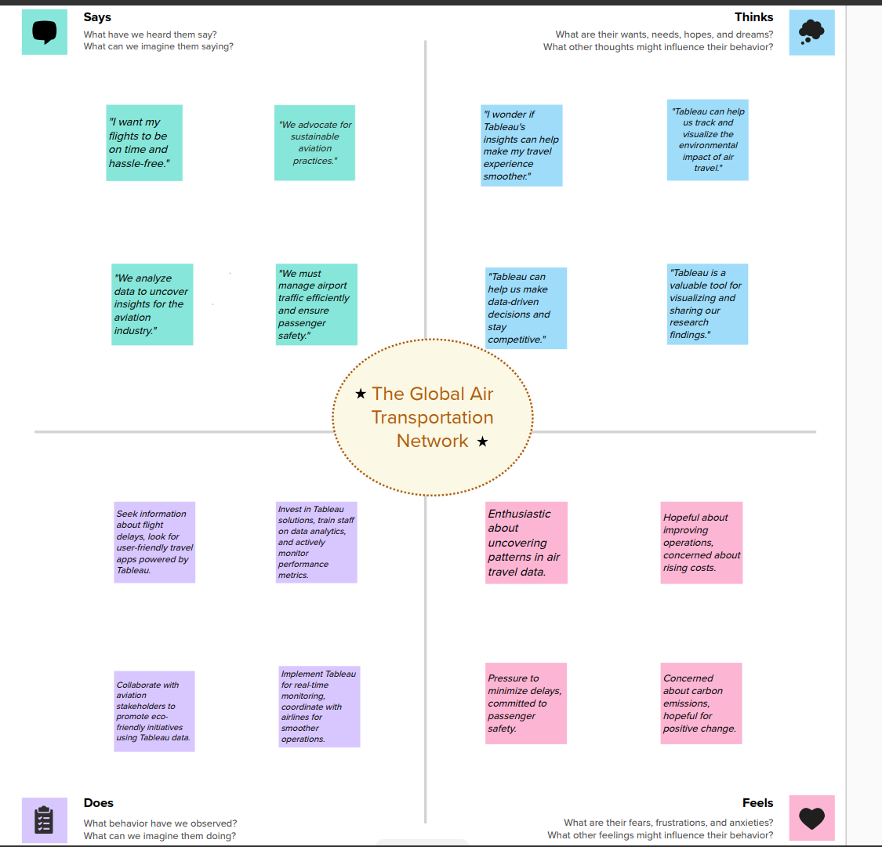

**2.2 Ideation & Brainstorming Map**

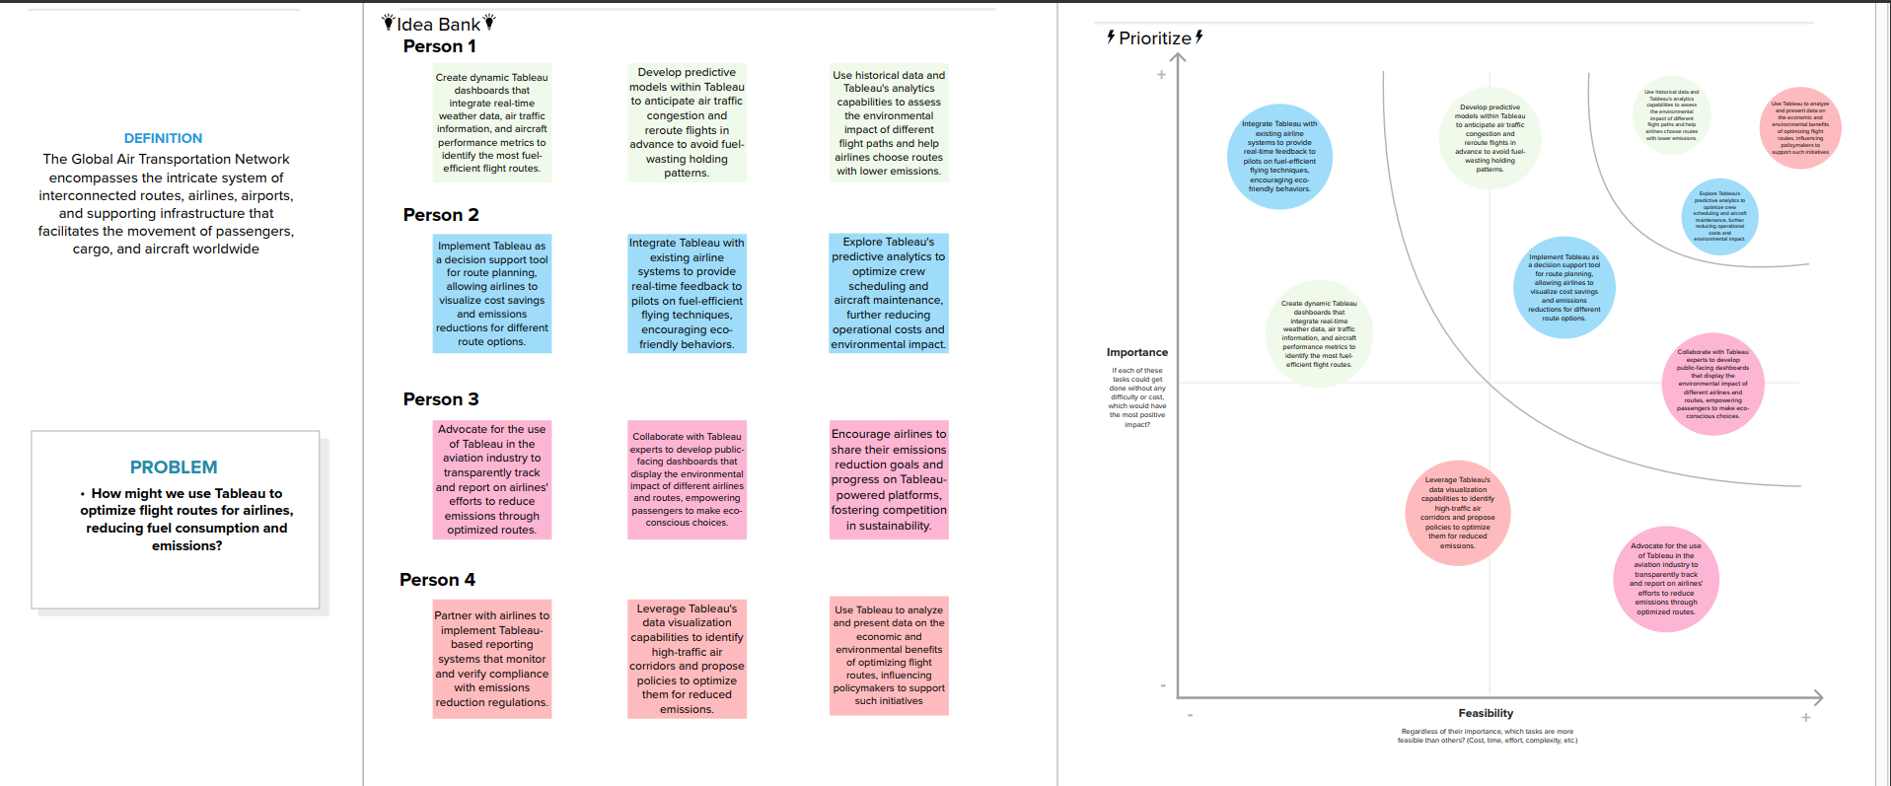

**3. RESULT**

**Sheet 1**

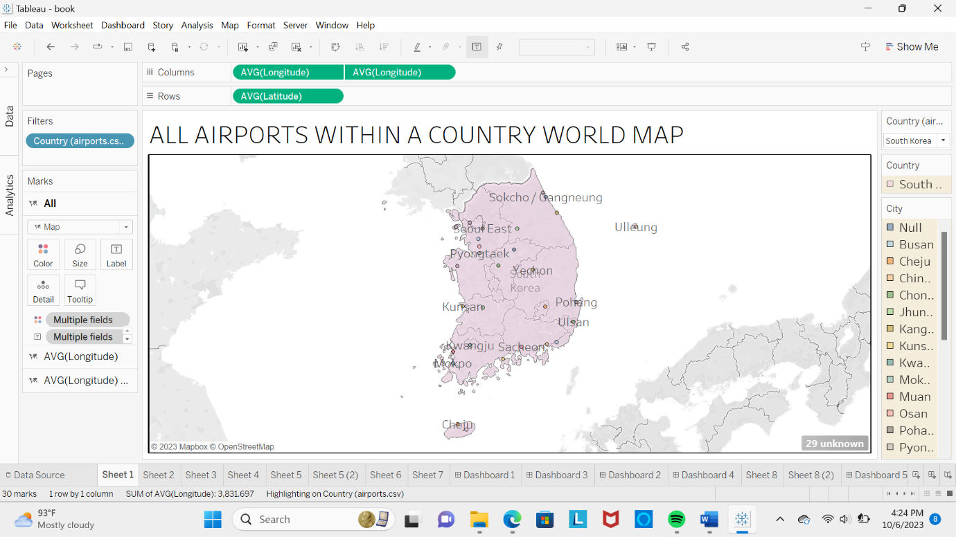

**Sheet 2**

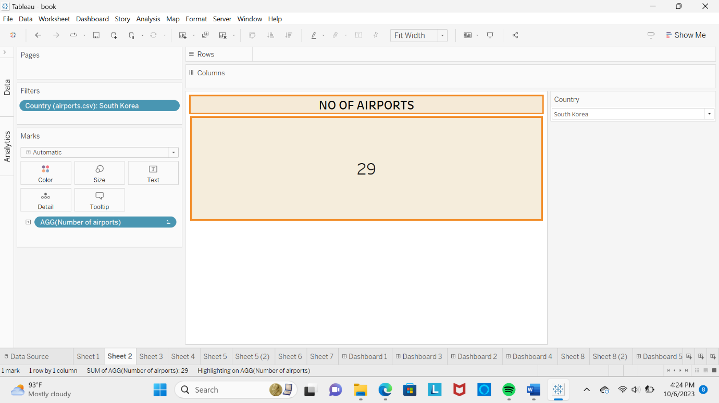

**Sheet 3**

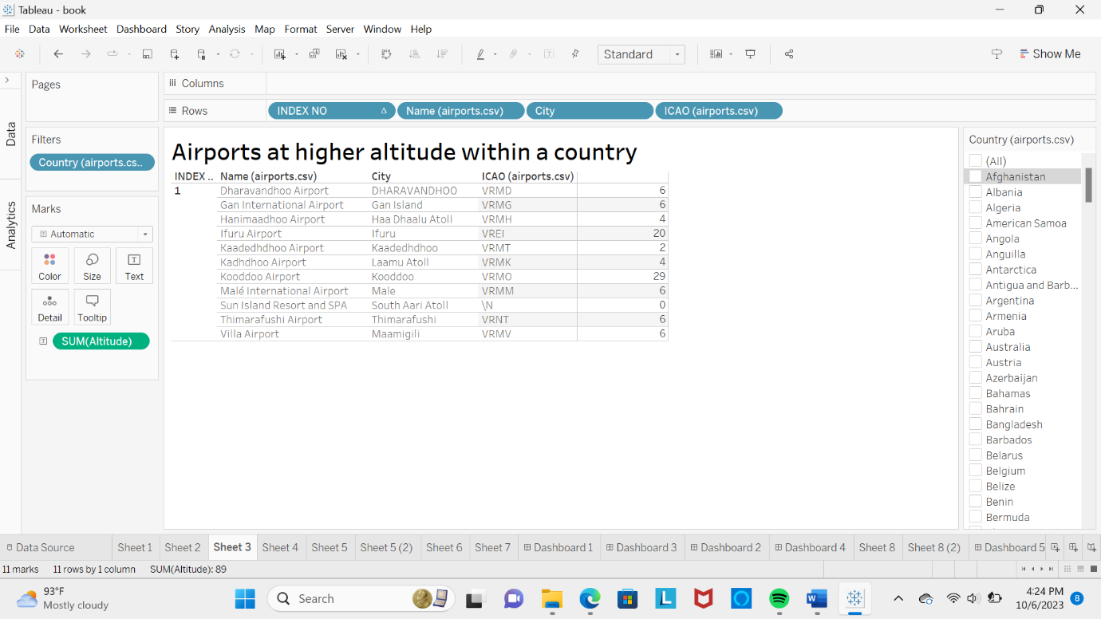

**Sheet 4**

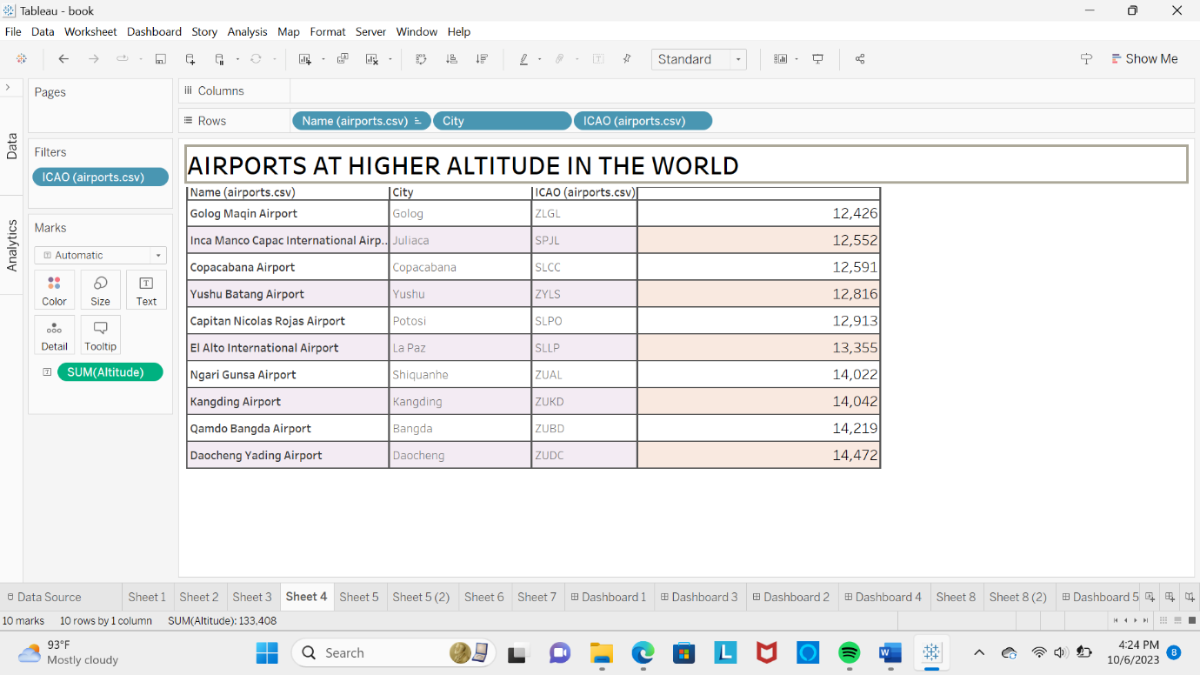

**Sheet 5(1)**

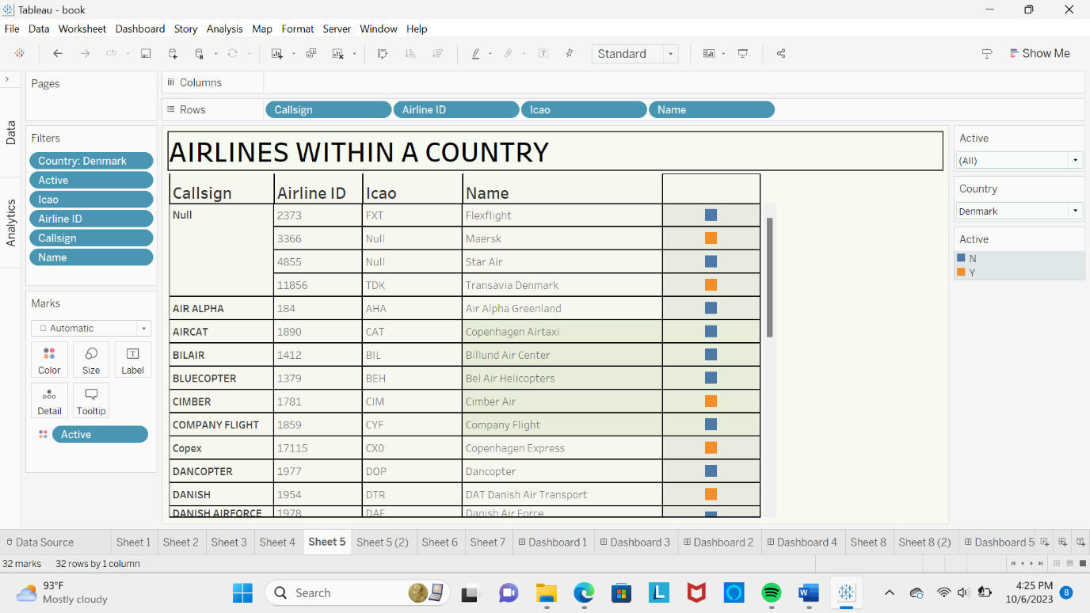

**Sheet 5(2)**

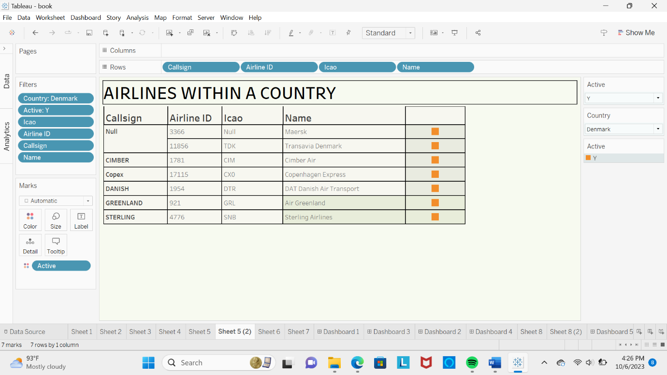

**Sheet 6**

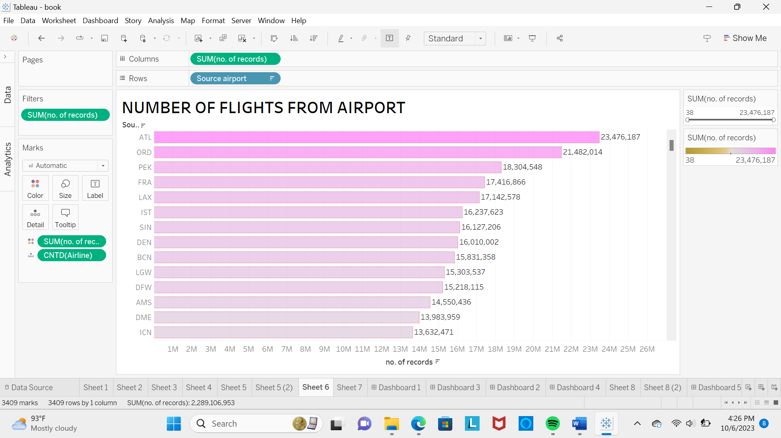

**Sheet 7**

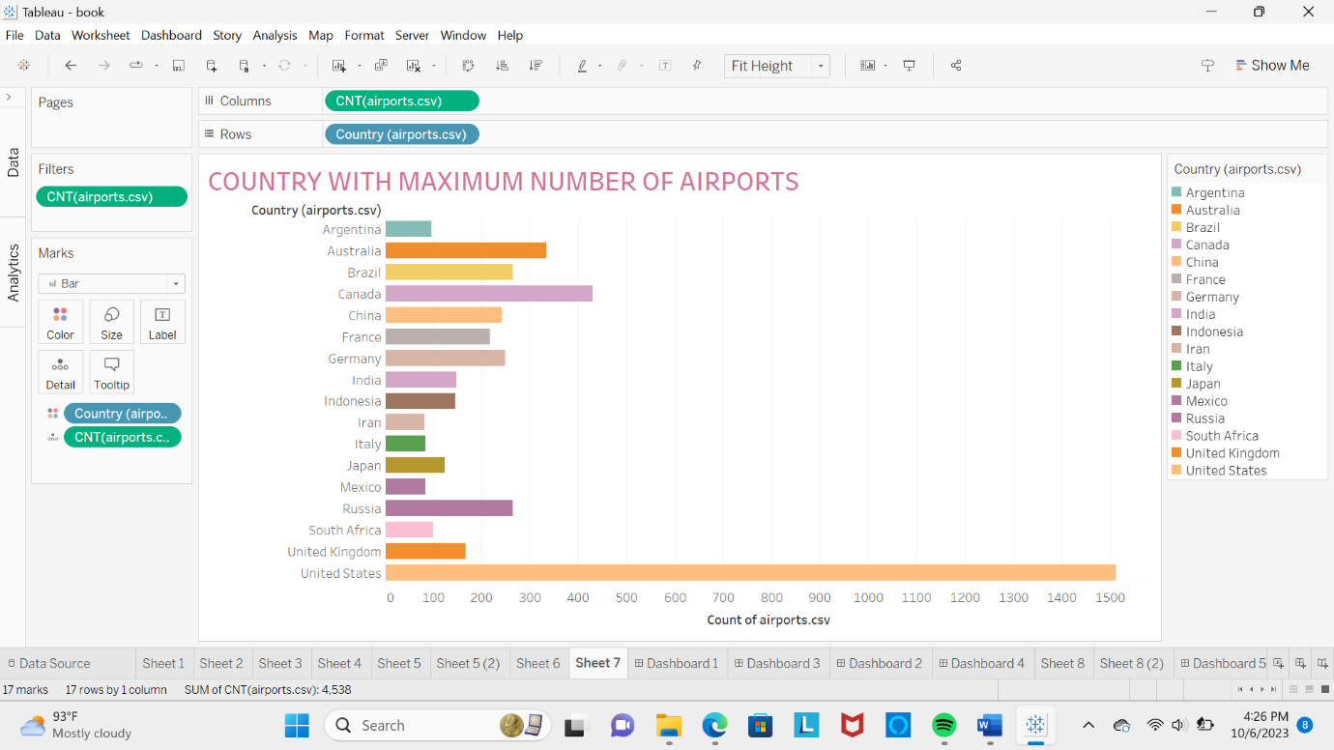

**Sheet 8(1)**



**Sheet 8(2)**



**Dashboard 1**

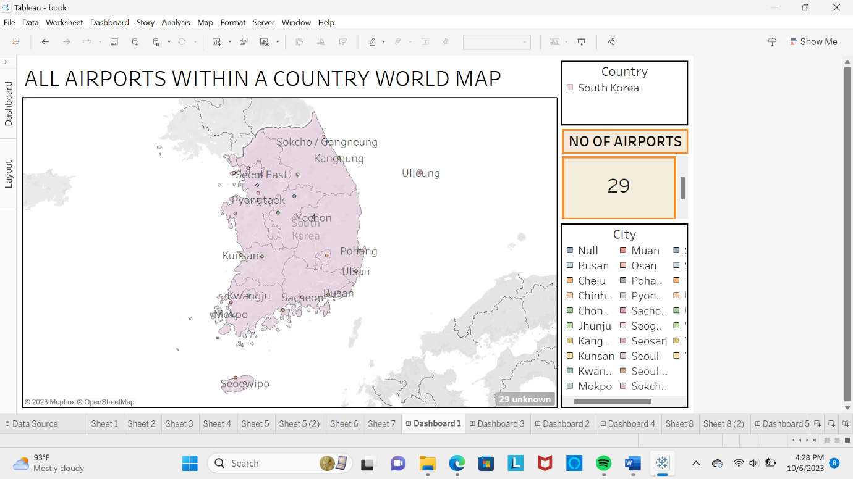

**Dashboard 2**

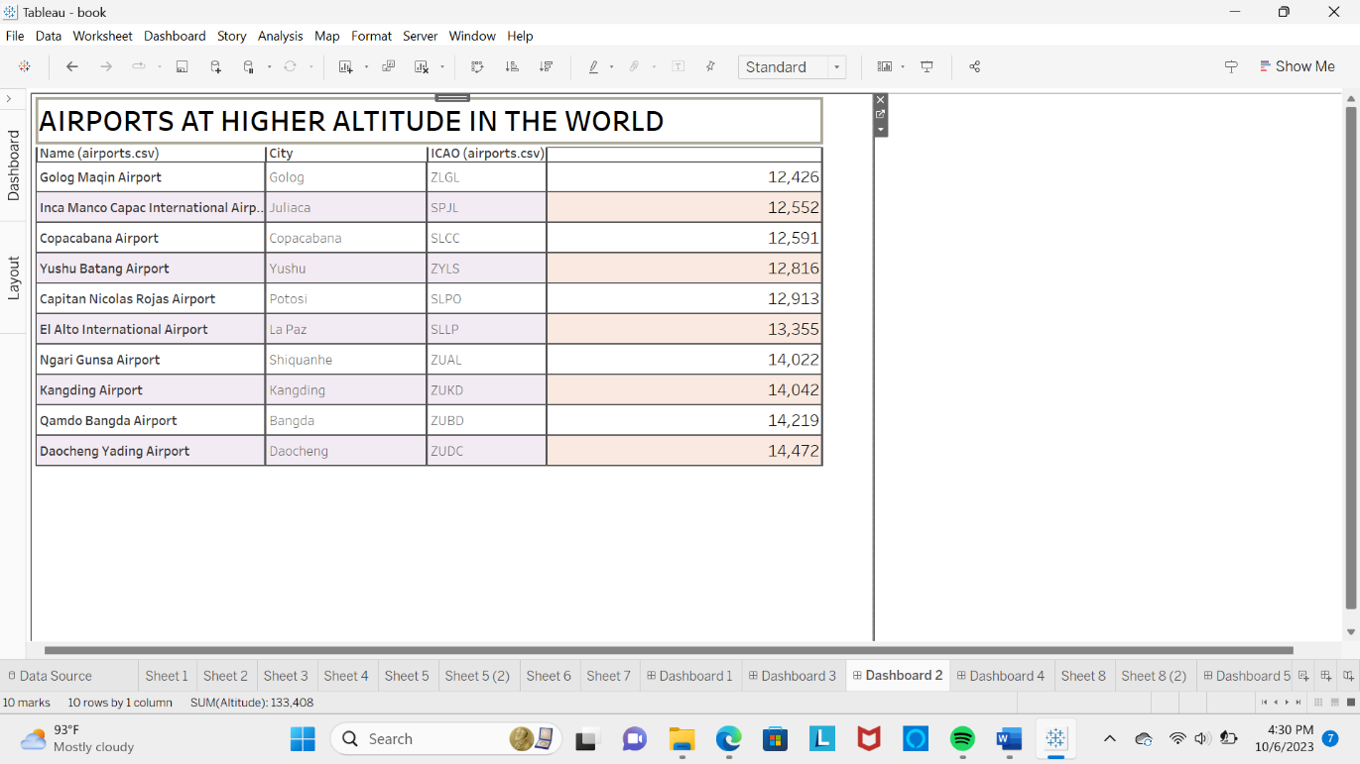

**Dashboard 3**

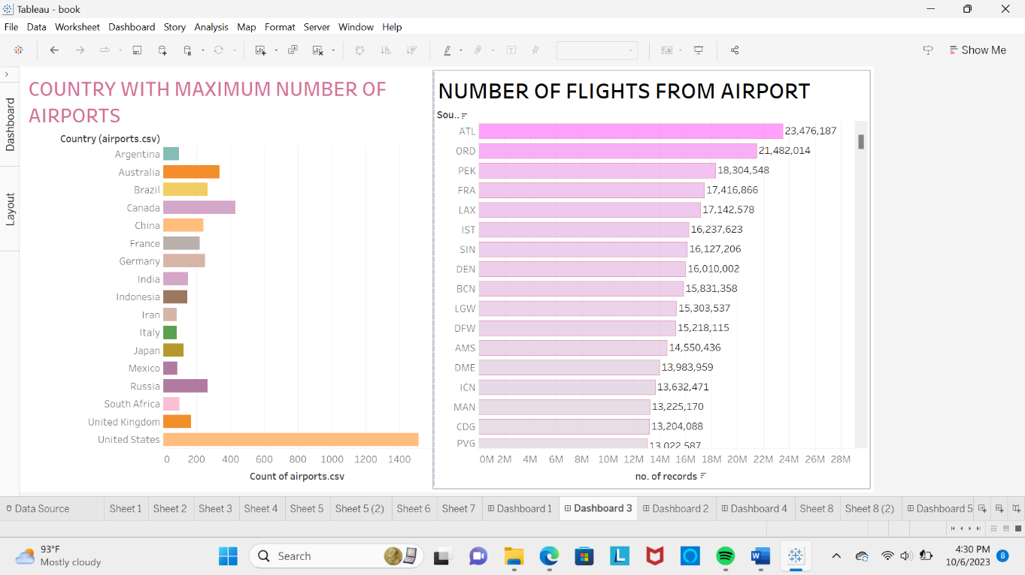

**Dashboard 4**

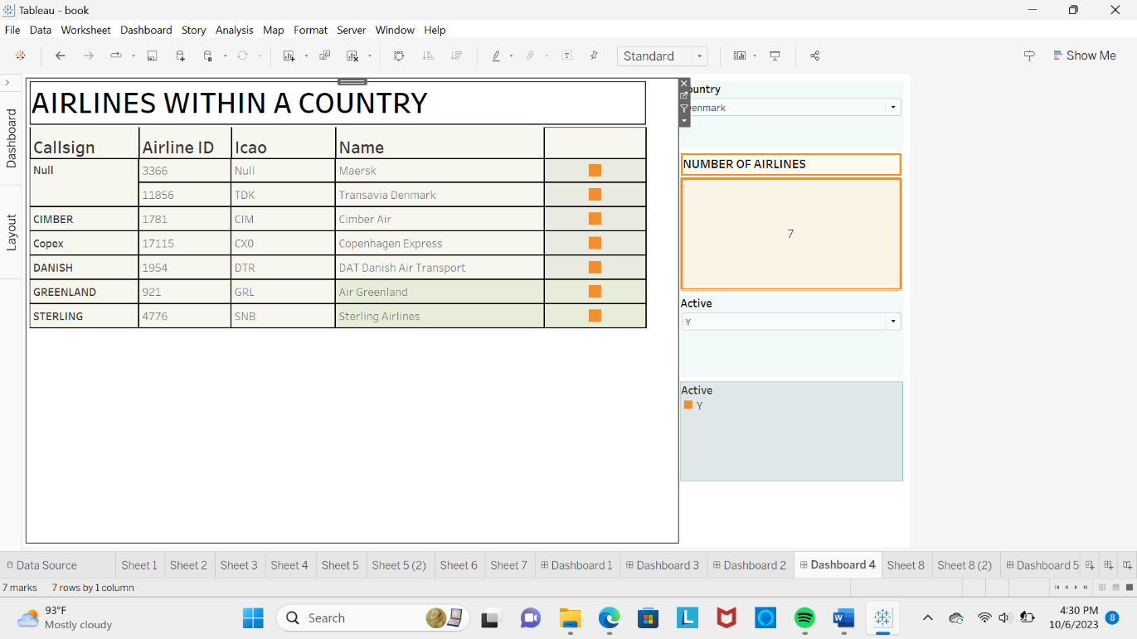

**Dashboard 5**

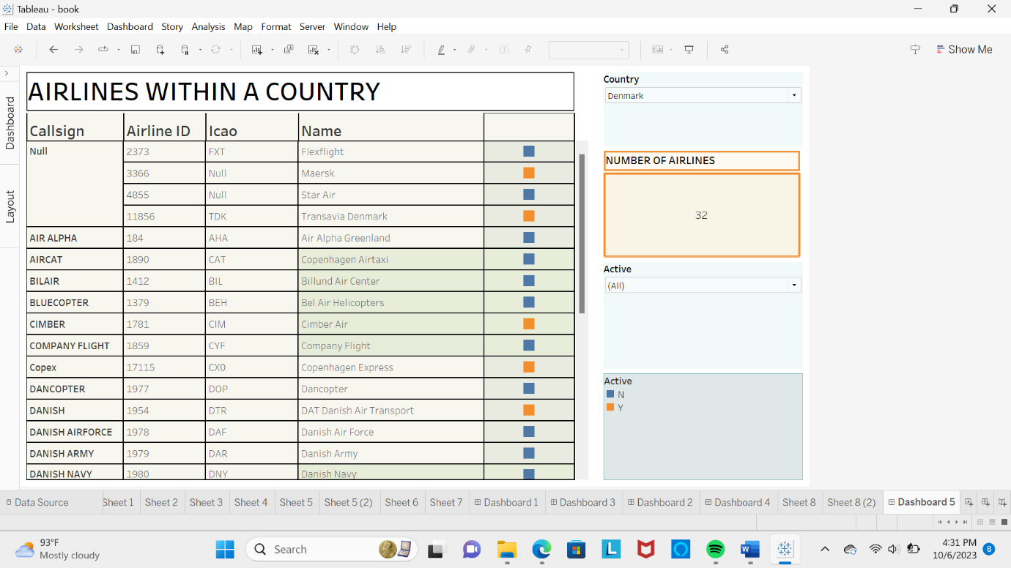

**Story**

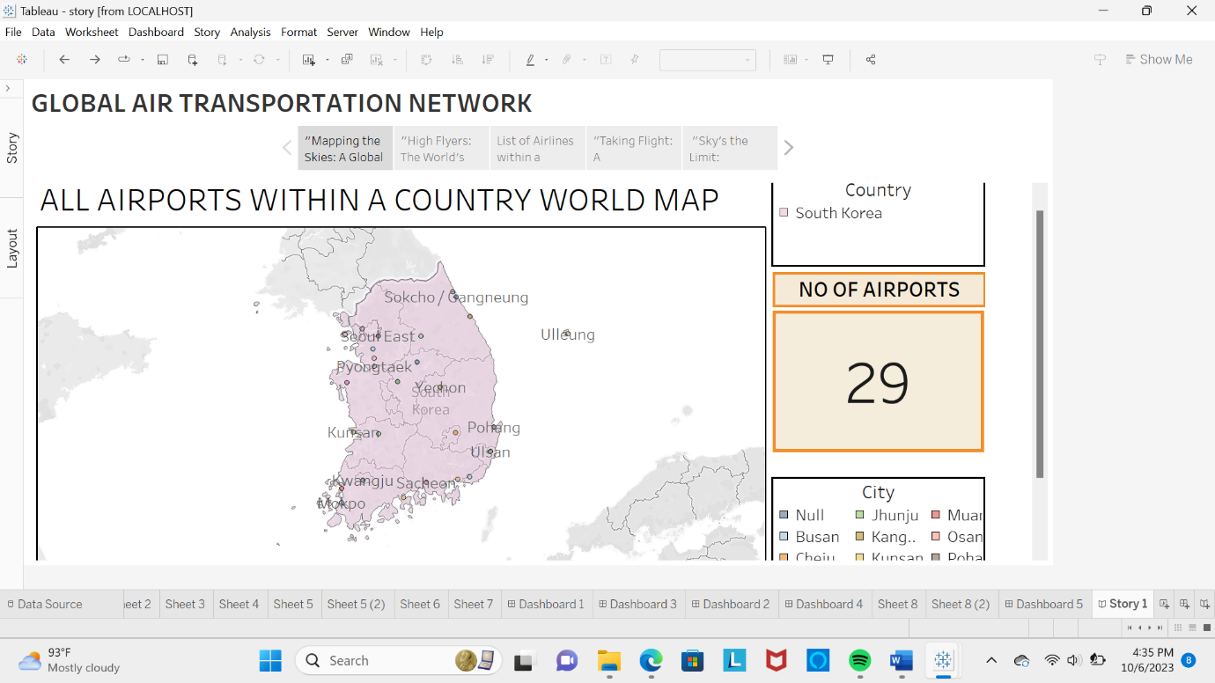

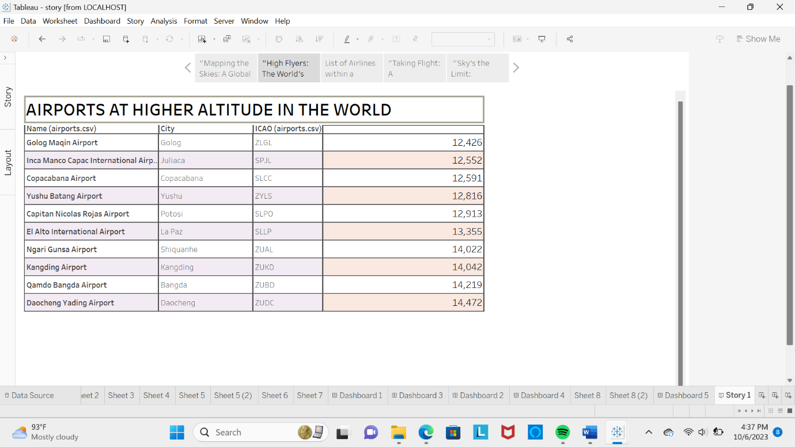

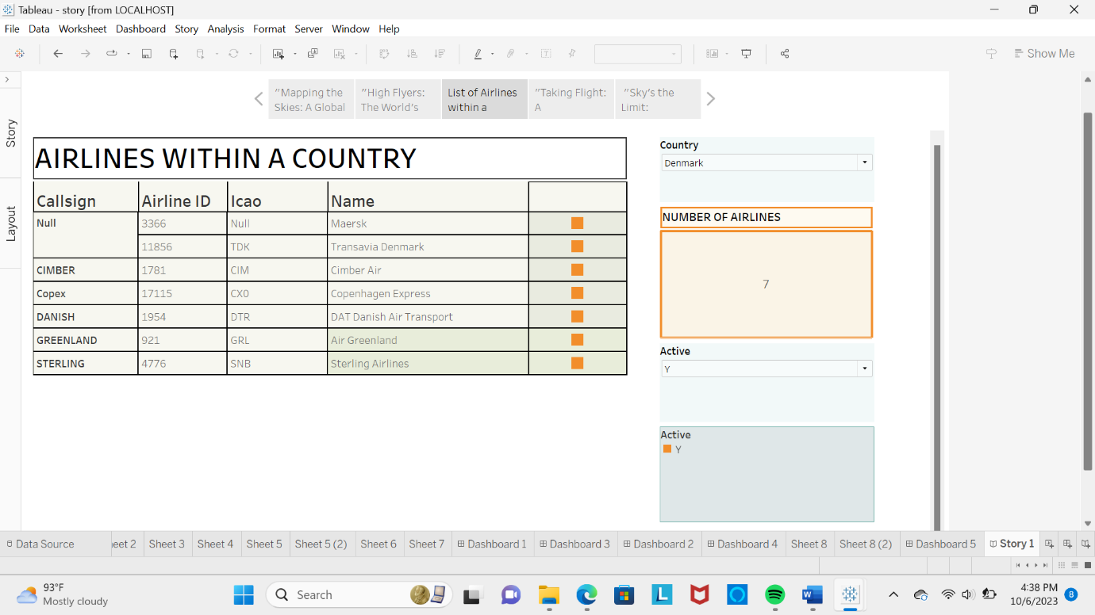

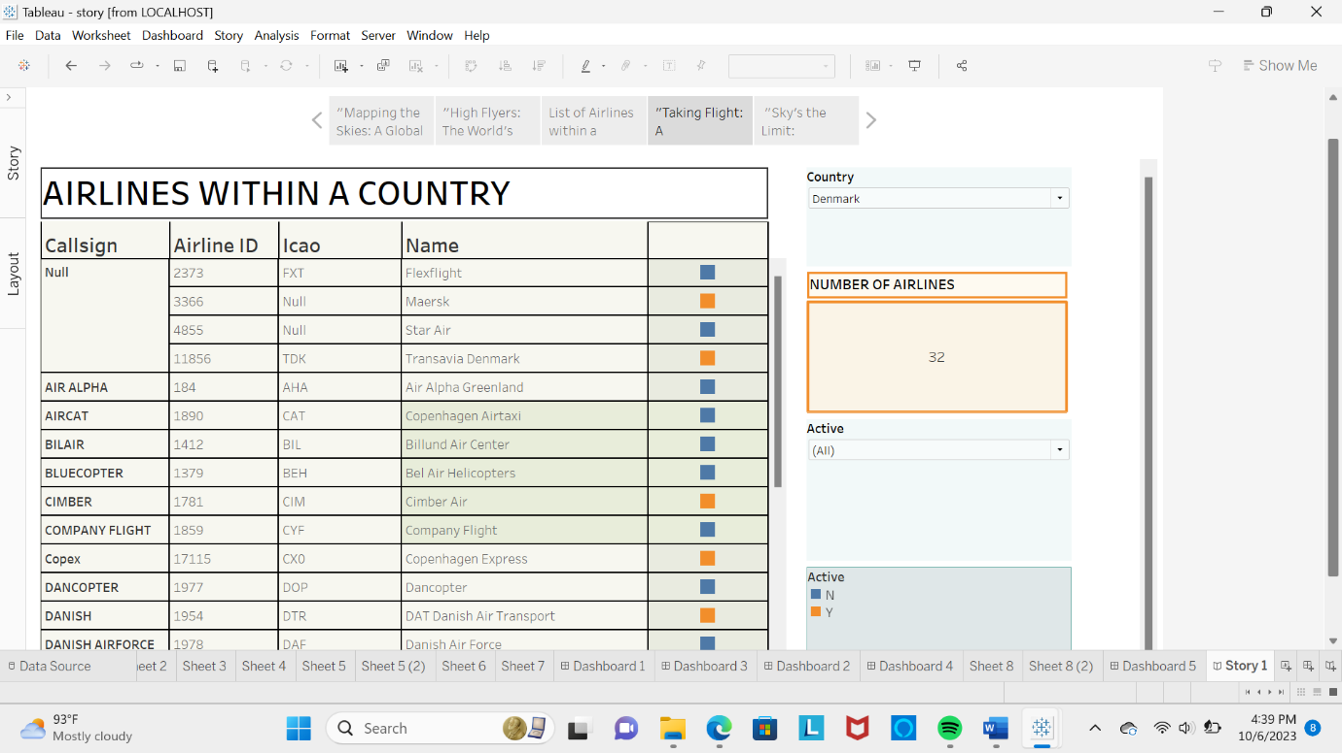

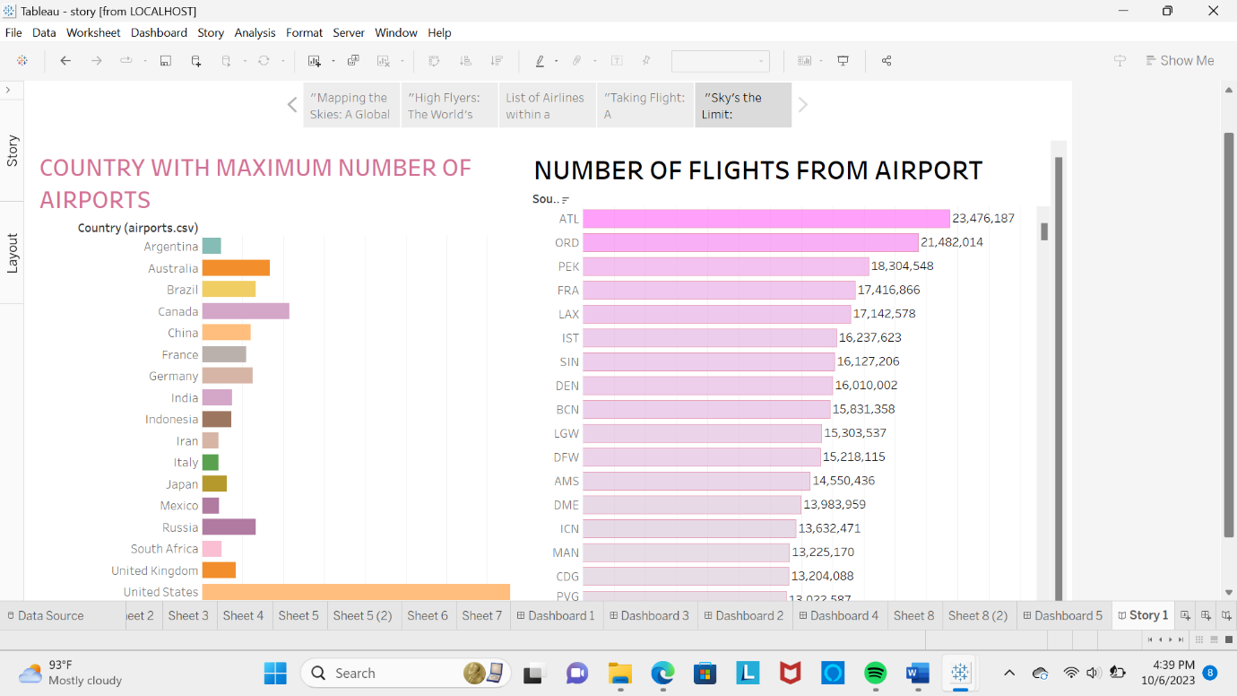

**4. ADVANTAGES AND DISADVANTAGES**

**4.1 Advantages**

**1 Enhanced Safety:**

* One of the most significant advantages of unlocking insights into the global air transportation network is enhanced safety. Analyzing historical data, flight patterns, and maintenance records can lead to the identification of potential safety hazards. This allows airlines and regulatory bodies to implement proactive safety measures, reducing the risk of accidents and incidents.

**2 Improved Efficiency:**

* Access to real-time data about flight delays, congestion at airports, and weather conditions can lead to improved operational efficiency. Airlines can optimize flight schedules, reduce fuel consumption, and minimize delays, leading to cost savings and a better passenger experience.

**3 Environmental Benefits:**

* By gaining insights into air transportation, it is possible to identify opportunities for reducing the environmental impact of aviation. This includes optimizing flight paths, reducing emissions, and developing more fuel-efficient aircraft, contributing to sustainability efforts.

**4 Economic Impact:**

* A better understanding of the global air transportation network can have a positive economic impact. It can lead to increased tourism, job creation, and growth in related industries. Additionally, data-driven decision-making can help governments and airlines allocate resources more efficiently.

**5 Strategic Planning:**

* Insights into the air transportation network enable governments, airlines, and airports to make informed decisions about infrastructure development and expansion. This leads to better long-term planning, reducing bottlenecks and congestion.

**4.2 Disadvantages**

**1 Privacy Concerns:**

* Collecting and analyzing data on air travelers can raise significant privacy concerns. Passengers may be uncomfortable with the idea of their personal information and travel history being monitored and analyzed without their consent.

**2 Data Security Risks:**

* The vast amount of data involved in analyzing the global air transportation network creates data security risks. Breaches could lead to the exposure of sensitive passenger information, making it essential to invest in robust security measures.

**3 Misuse of Information:**

* There is a risk that the insights gained from this data could be misused. Governments or organizations could use the information for surveillance, discrimination, or profiling, leading to potential ethical and legal dilemmas.

**4 Cost and Resource Intensiveness:**

* Gathering and analyzing data on a global scale is costly and resource-intensive. Small airlines and underdeveloped regions may struggle to keep up with the technological demands, potentially exacerbating inequalities in the industry.

**5 Ethical Dilemmas:**

* Unlocking insights into the global air transportation network raises ethical dilemmas surrounding passenger consent, data ownership, and the balance between public safety and individual privacy.

**5.APPLICATION**

1. **Route Optimization**: Airlines and logistics companies can use insights into the air transportation network to optimize their flight routes. This can lead to fuel savings, reduced emissions, and shorter travel times.
2. **Airport Planning**: Understanding traffic patterns and connectivity between airports can help in the planning and expansion of airport infrastructure. It can also aid in predicting future demand for services and facilities.
3. **Market Research**: Businesses can use data on air transportation networks to conduct market research. For example, they can analyze which regions are most accessible by air, helping them identify potential markets for their products or services.
4. **Disaster Response**: During natural disasters or emergencies, insights into the air transportation network can be crucial for coordinating relief efforts and ensuring that resources reach affected areas efficiently.
5. **Environmental Impact Assessment**: Researchers can use data on the air transportation network to assess the environmental impact of aviation, such as carbon emissions and noise pollution, and develop strategies for mitigation.
6. **Tourism Development**: Tourism boards and travel agencies can use this data to identify popular travel routes and destinations. They can also promote lesser-known destinations that may become more accessible through improved air connectivity.
7. **Security and Surveillance**: Governments and security agencies can monitor air traffic for security purposes. Analyzing patterns and anomalies in the air transportation network can help identify potential threats.
8. **Supply Chain Management**: Companies involved in international trade and shipping can use insights into the air transportation network to optimize their supply chain, ensuring timely delivery of goods.
9. **Urban Planning**: City planners can consider air transportation networks when designing urban infrastructure. Access to airports and heliports can impact the accessibility and attractiveness of different areas within a city.
10. **Healthcare Logistics**: Understanding the global air transportation network is crucial for the efficient transport of medical supplies, including vaccines and organs for transplantation, particularly on an international scale.
11. **Investment and Finance**: Investors and financial analysts can use data on air transportation networks to make informed decisions about investing in airlines, airport infrastructure, or related industries.
12. **Climate Change Research**: Researchers studying climate change can utilize information about air transportation networks to assess the contribution of aviation to greenhouse gas emissions and explore ways to reduce its impact.
13. **Education and Training**: Aviation schools and training centers can use insights into the air transportation network to develop realistic training scenarios for pilots, air traffic controllers, and aviation management students.
14. **Aircraft Design**: Aerospace engineers and manufacturers can benefit from understanding air transportation networks to design more efficient and suitable aircraft for specific routes and markets.
15. **Crisis Management**: Government agencies can use insights into air transportation networks during crisis situations, such as pandemics or geopolitical conflicts, to manage evacuations or repatriations.

Unlocking insights into the global air transportation network is a multidisciplinary field with applications in transportation, economics, security, environmental science, and many other areas. It has the potential to drive innovation and improve the efficiency and sustainability of air travel.

**6.CONCLUSION**

In conclusion, unlocking insights into the global air transportation network is not just a matter of convenience or efficiency; it is a critical endeavor with far-reaching implications for our interconnected world. By harnessing the power of data analytics, advanced technologies, and collaborative efforts across borders, we can not only optimize air travel but also enhance safety, reduce environmental impact, and improve overall global connectivity. As we continue to delve deeper into the complexities of this intricate network, we are poised to unlock new opportunities for innovation, sustainability, and global cooperation. In doing so, we pave the way for a brighter future where the skies are more accessible, efficient, and interconnected than ever before.

**7.FUTURE SCOPE**

Unlocking insights into the global air transportation network is a crucial area with immense future scope. The aviation industry is constantly evolving, driven by technological advancements, environmental concerns, and changing consumer preferences. Here are some potential future developments and opportunities for this topic:

1. **Advanced Data Analytics**: With the increasing availability of data from various sources like flight records, weather data, and passenger information, the use of advanced data analytics, including artificial intelligence and machine learning, will play a pivotal role in gaining deeper insights into the global air transportation network. Predictive analytics can be used for better route optimization, maintenance scheduling, and passenger demand forecasting.
2. **Sustainable Aviation**: Environmental concerns and the need to reduce greenhouse gas emissions are driving innovations in sustainable aviation. The future will likely see the integration of cleaner and more efficient aircraft, biofuels, and electric propulsion systems. Unlocking insights into how these technologies impact the global air transportation network and the associated economic and environmental implications will be essential.
3. **Urban Air Mobility (UAM)**: The development of UAM, including electric vertical take-off and landing (eVTOL) aircraft, is poised to revolutionize the way people commute within cities. Understanding how UAM integrates with traditional air transportation and urban infrastructure will be crucial for efficient network management.
4. **Airport Operations and Infrastructure**: Optimizing airport operations, runway scheduling, and terminal design will continue to be a significant area of research. AI-powered solutions can help manage congestion, reduce delays, and enhance passenger experiences.
5. **Global Connectivity**: The ongoing expansion of global air routes and airline networks presents opportunities and challenges. Studying the trends in airline alliances, hub airports, and long-haul versus short-haul routes can provide insights into the evolving landscape of global connectivity.
6. **Passenger Behavior Analysis**: Understanding passenger behavior and preferences will be critical for airlines and airports to enhance customer satisfaction and loyalty. This includes analyzing factors like booking patterns, in-flight services, and the impact of external events (e.g., pandemics) on passenger demand.
7. **Regulatory and Security Aspects**: The future of air transportation will also depend on how regulatory bodies adapt to emerging technologies and security threats. Research into the impact of regulations on network efficiency and safety will remain important.
8. **Space Travel Integration**: As space tourism and commercial space travel become more accessible, there will be a need to examine how these activities intersect with traditional air transportation networks, including airspace management and potential new spaceports.
9. **Resilience and Disaster Management**: Investigating the resilience of the global air transportation network in the face of natural disasters, pandemics, or other unforeseen events will be crucial for ensuring continuity of services and safety.
10. **Public-Private Collaboration**: Future research may explore how public and private sector collaboration can improve the efficiency and sustainability of the air transportation network. This could involve partnerships in research and development, infrastructure investment, and policy formulation.

In summary, the future scope for unlocking insights into the global air transportation network is vast and multi-faceted. As technology, environmental concerns, and passenger preferences continue to evolve, ongoing research and analysis in this field will be essential for shaping a more efficient, sustainable, and resilient global air transportation network.

Top of Form